**4.1 Carbohydrate Classification\***

Nomenclature

* Organized by their number of carbon atoms and functional groups
* E.g. glucose, fructose, galactose
* Three-carbon sugars = trioses, four-carbon sugars = tetroses, etc
* Sugars with aldehydes as their most oxidized group are **aldoses**
  + Simplest aldose = glyceraldehyde
* Sugars with ketones as their most oxidized group are **ketoses**
  + Simplest ketose = dihydroxyacetone

Stereochemistry

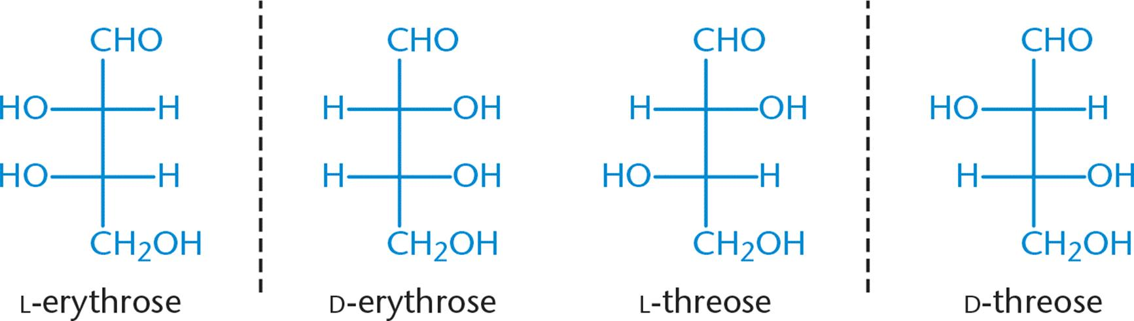

(Four stereoisomers of an Aldotetrose)

* D-erythrose and L-erythrose
  + Non-superimposable mirror images of one another = enantiomers
* D-erythrose and D-threose (or L-erythrose and D-threose)
  + Not mirror images, but still non-superimposable = diastereomers
  + Also differ in configuration at only one chiral centre = epimer (subtype of diastereomer)

**4.2 Cyclic Sugar Molecules**

Hexose Conformations

* Cyclization describes ring formation of carbohydrates from their straight-chain forms
* When rings form, the anomeric carbon (which is the carbon containing the carbonyl in the straight-chain form) can take on either an α- or β- conformation
  + The anomeric carbon is the new chiral centre formed in ring closure
* When converting the monosaccharide from its straight-chain Fischer projection to the Haworth project, any group on the right in the Fischer projection will point down

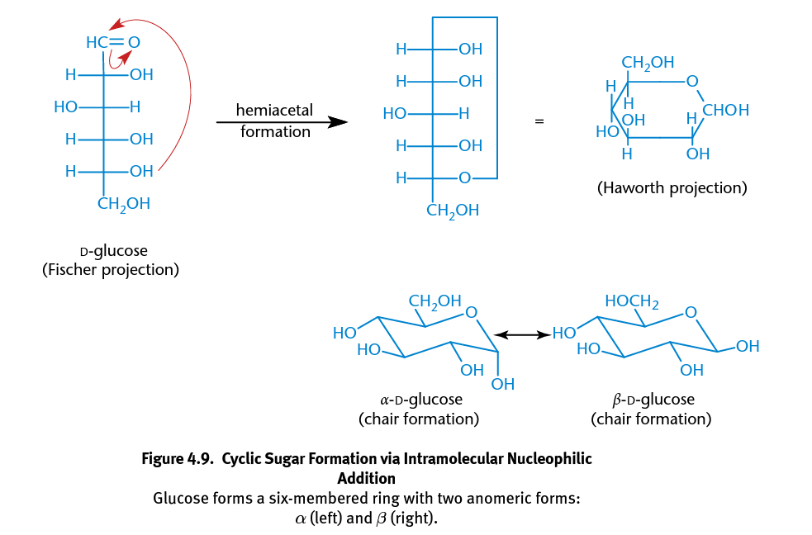

Mutarotation

* Cyclic compounds can undergo mutarotation, in which they shift from one anomeric form to another with the straight-chain form as an intermediate
  + This happens when hemiacetal rings are exposed to water, which causes them to spontaneously cycle between the open and closed form
  + Because the substituents on the single bond between C-1 and C-2 can rotate freely, either the α- or β- anomer can be formed

**4.3 Monosaccharides**

Oxidation and Reduction

* Can be oxidized to aldonic acids, and reduced to alditols
* Sugars (i.e. contains aldehyde) that can be oxidized = reducing agents (i.e. reducing sugars), and can be detected using:
  + Tollen’s reagent (will turn silver)
  + Benedict’s reagent (will produce red precipitate of Cu2O)
* Ketose are also considered reducing sugars because they can tautomerize to form aldose under basic conditions, via keto-enol shifts → can react with the reagents to form the carboxylic acid

Esterification

* Carbohydrates have **hydroxyl groups that react with carboxylic acids** and carboxylic acid derivatives to form esters
* Similar to phosphorylation of glucose → forms phosphate ester

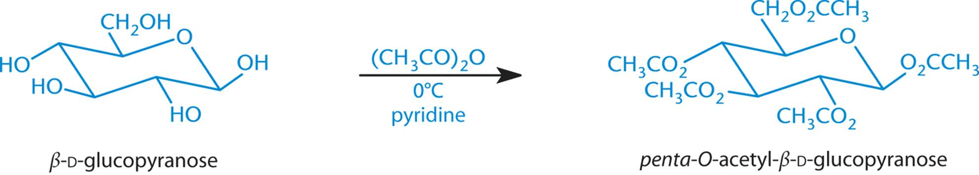

(Esterification of glucose using acetic anhydride)

Glycoside Formation

* **Hemiacetal (or hemiketal) sugars react with alcohols** under acidic conditions to form acetals (or ketals)
* The anomeric hydroxyl group is transformed into an alkoxy group
* The resulting C-O bonds are called **glycosidic bonds**

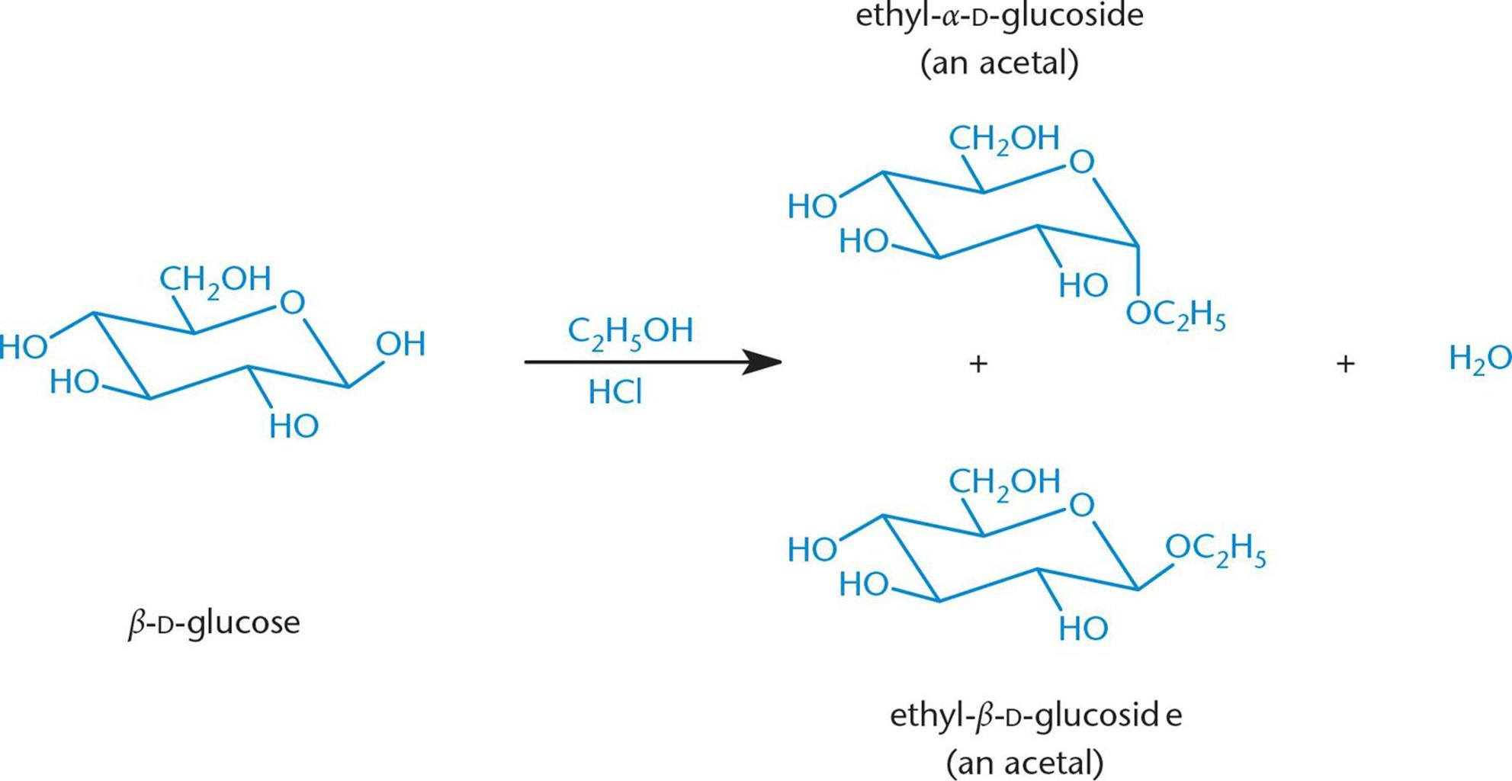

**4.4 Complex Carbohydrates\***

Disaccharides

* Form as a result of glycosidic bonding between two monosaccharide subunits
* Common disaccharides:
  + Sucrose = glucose-α-1,2-fructose
  + Lactose = galactose-β-1,4-glucose
  + Maltose = glucose-α-1,4-glucose

Polysaccharides

* Form by repeated monosaccharide or polysaccharide glycosidic bonding
* Cellulose
  + Main structural component of plant cell walls and is a main source of fiber in the human diet
* Starches (amylose and amylopectin)
  + Function as a main energy storage form for plants
* Glycogen
  + Functions as a main energy storage form for animals
  + Similar to starch, but with more α-1,6 glycosidic bonds → highly branched
    - Optimizes the energy efficiency
    - Makes it more soluble in solution (for more efficient storage in the body)
    - Allows enzymes that cleave glucose from glycogen to work on many sites within the molecule simultaneously